Name: Jamie Anthony Brindle
Student ID: 06352322
Title: Website Development: Online Bookshop Assignment 1 Demonstration and Testing
Favourites and Ordering Books

Adding To Favourites: Add from book search (not logged in)
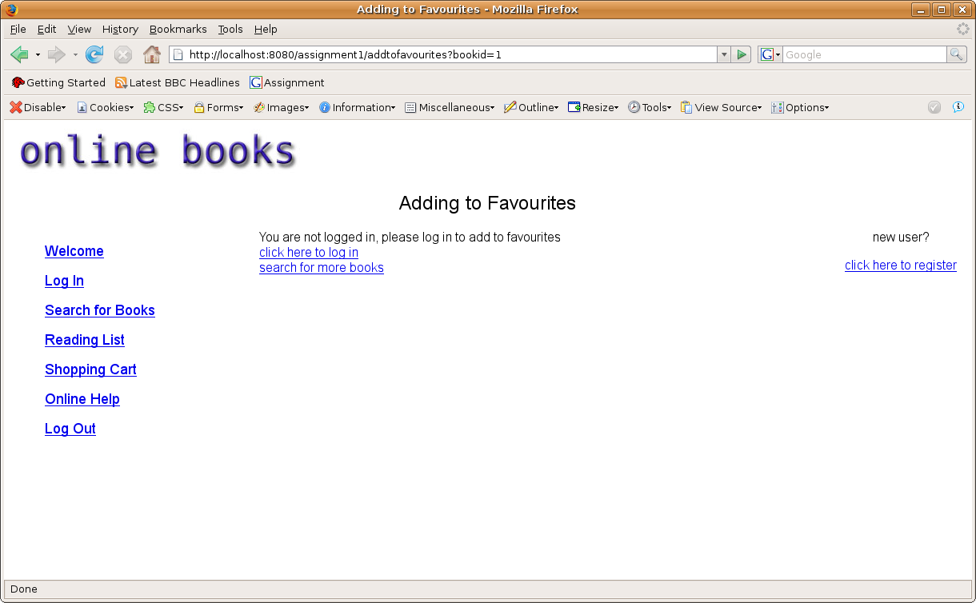
If user not logged in, message appears asking user to log in

Adding to Favourites: Add from book search (logged in)
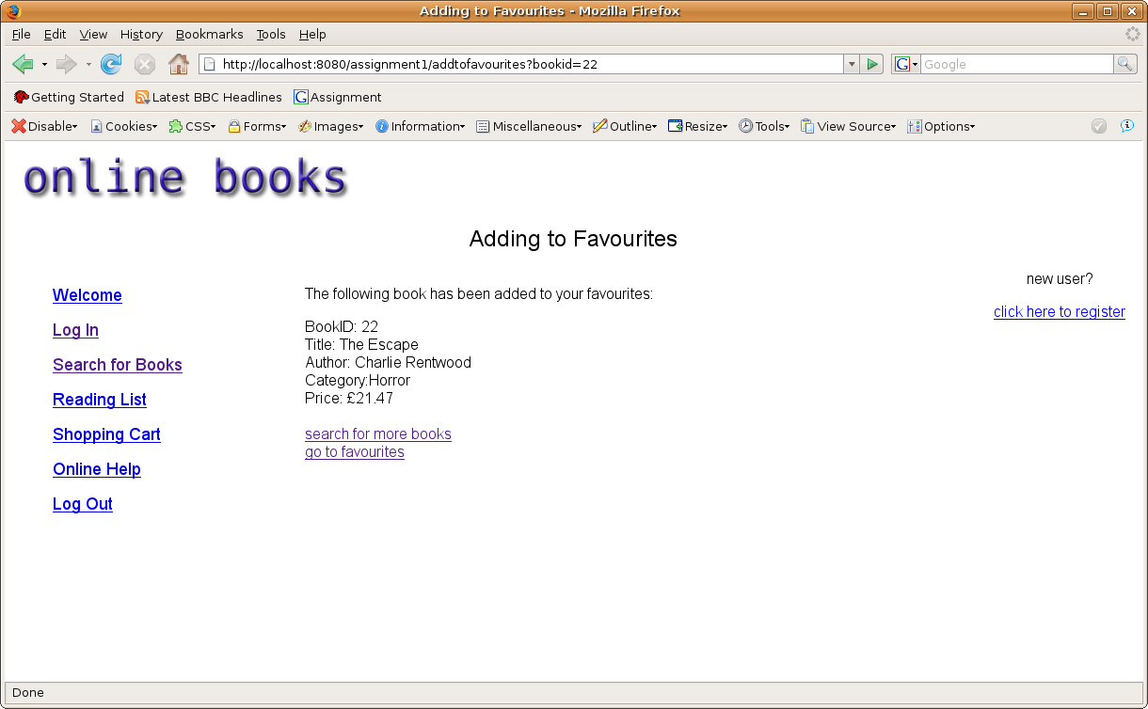
Confirmation of book been added to favourites appears, books are saved in mysql database

Adding to Favourites: Double check to see if book is added to personal favourites
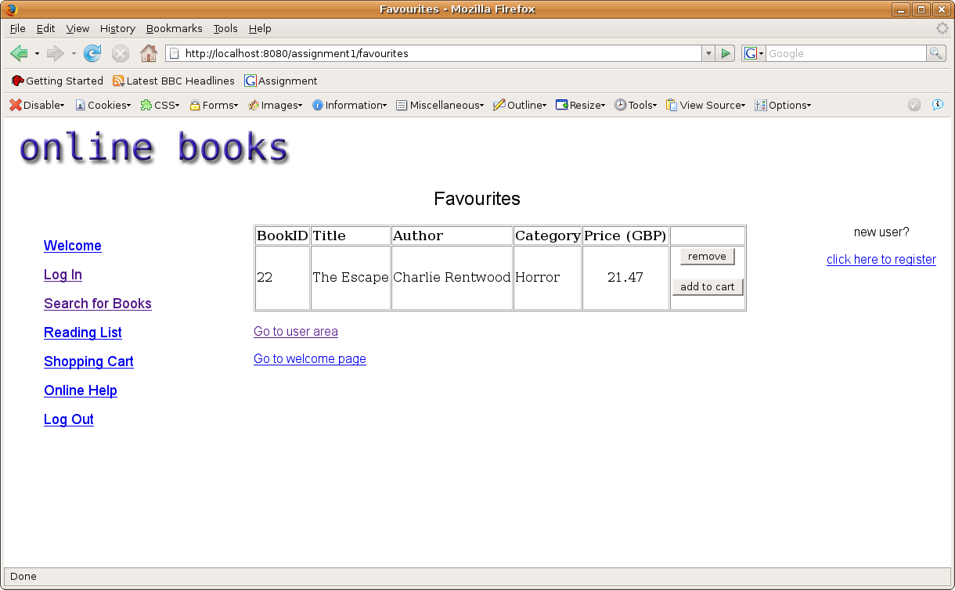
Book is shown in personal favourites as expected

Favourites: Adding to cart
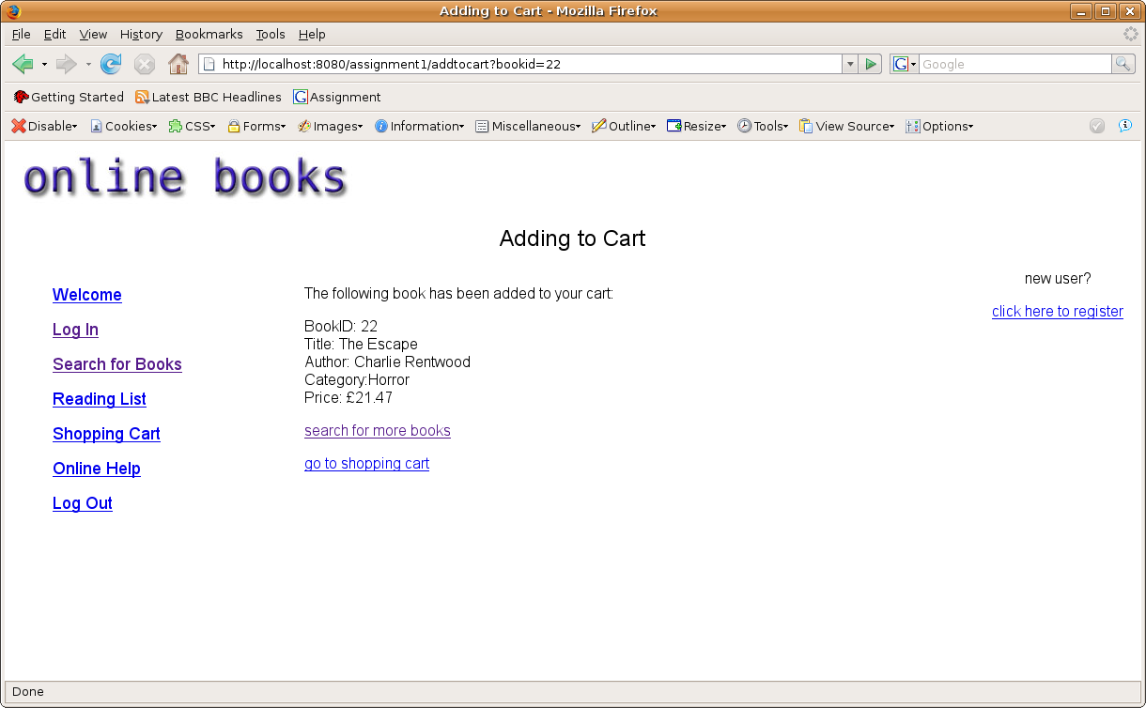
Confirmation of book been added to cart

Favourites: Check book been successfully added to cart
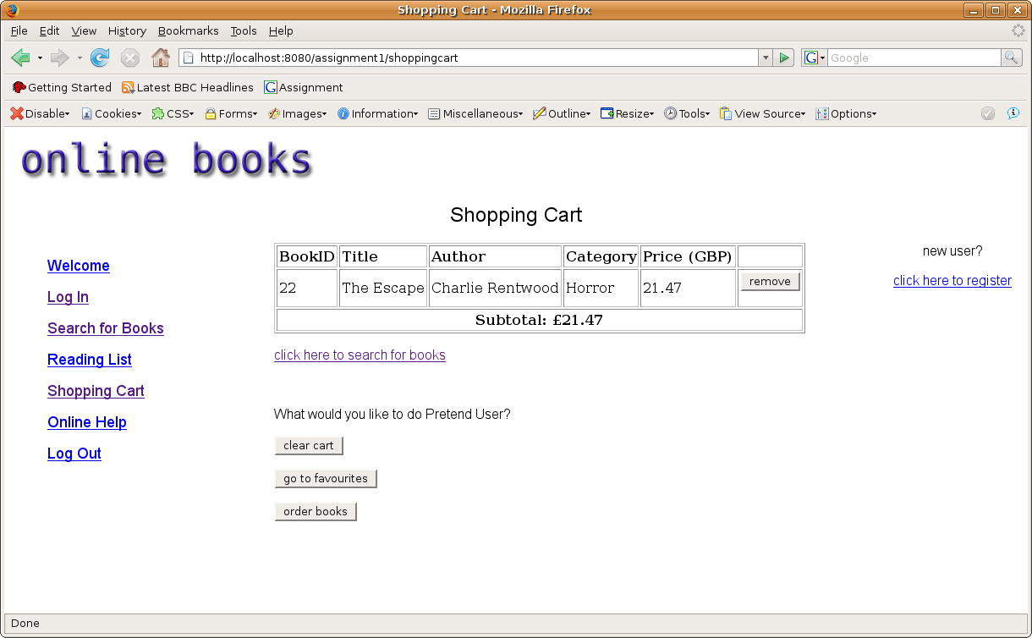
book been successfully added to cart

Favourites: Remove Book
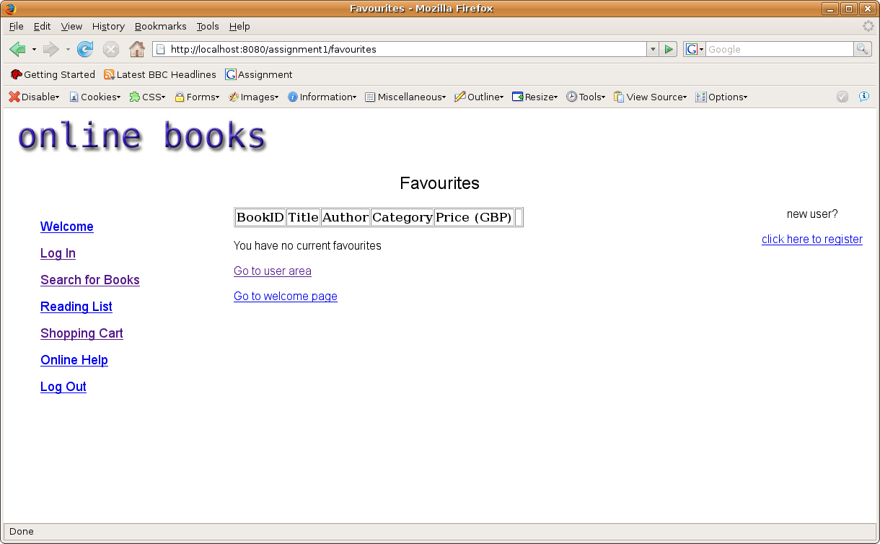
Book successfully removed and page updated, message appears stating no books in favourites

Ordering Books: Can only do when logged in, from shopping cart
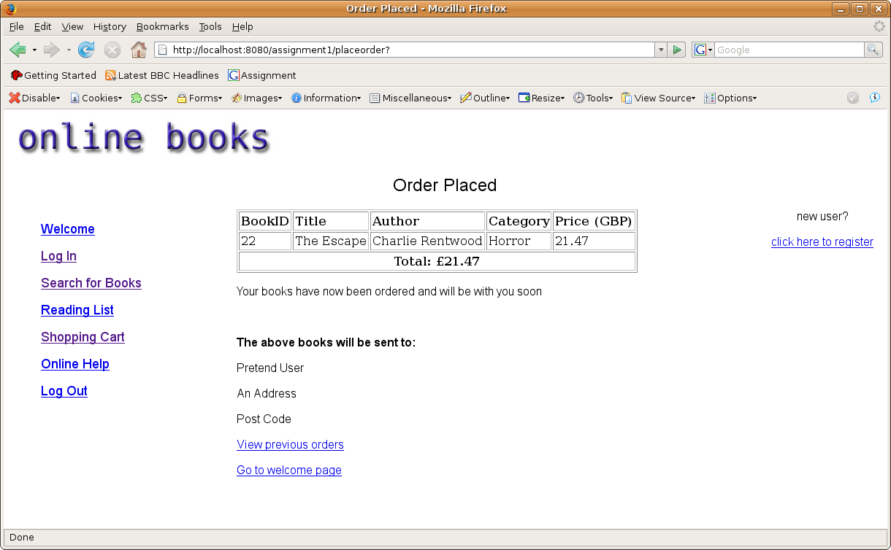
Confirmation of what books have been ordered appear and confirmation of the address the books will be sent to, option to view order history appears

Order History: Shows users previously ordered books (must be logged in to do so)
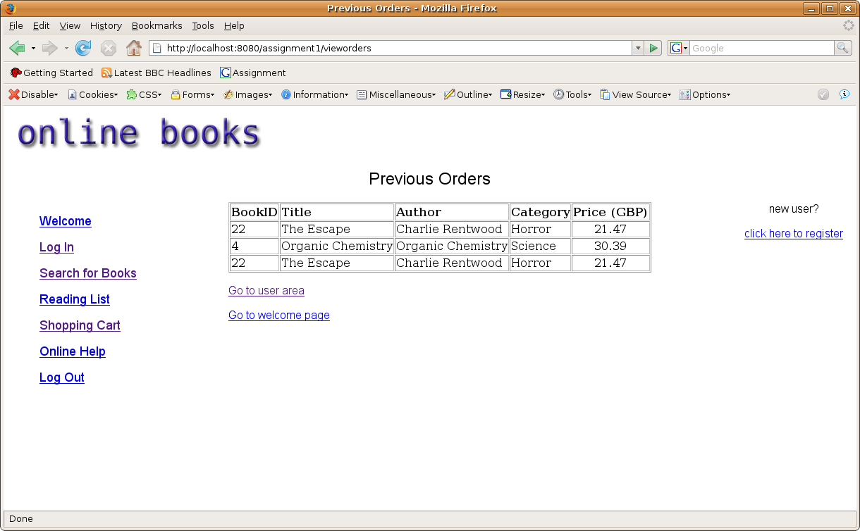
Gets orders stored in orders table in mysql database and shows in a table to the user

